**Task 1**

**Software Development Life Cycle**

Software Development Life Cycle (SDLC) is a process used by the software industry to design, develop and test high quality software and it can be done in various stages.

**1) Requirement Gathering and Analysis**

* During this phase, all the relevant information is collected from the customer to develop a product as per their expectation. Any ambiguities must be resolved in this phase only.

**2) Design**

* In this phase, the requirement gathered in the SRS document is used as an input and software architecture that is used for implementing system development is derived.

**3) Implementation or Coding**

* Implementation/Coding starts once the developer gets the Design document. The Software design is translated into source code. All the components of the software are implemented in this phase.

**4) Testing**

* Testing starts once the coding is complete and the modules are released for testing. In this phase, the developed software is tested thoroughly and any defects found are assigned to developers to get them fixed.

**Task 2**

1. **Verification** can be done by developer during the production whereas **validation** can be done be tester after product is ready
2. **Verification** saves time by detecting the defect at early stage whereas **validation** enables software teams to take corrective action if there is a mismatch between the actual product and the anticipated product
3. **Verification**: Verification is a static analysis technique. In this technique, testing is done without executing the code. Examples include – Reviews, Inspection, and walkthroughs.
4. **Validation**: Validation is a dynamic analysis technique where testing is done by executing the code. Examples include functional and non-functional testing techniques.

**Task 3**

**V-Model**

* In the V model, the development and QA activities are done simultaneously. There is no discrete phase called Testing, rather testing starts right from the requirement phase. The verification and validation activities go hand in hand.

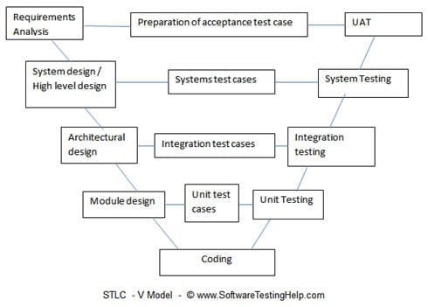

**Task 4**

**Defect –** The variation between the actual result and the expected result. If a developer finds an issue and corrected by himself in development phase, then it is called **defect**.

**Bug –** If a tester finds any mismatch in the application in the testing phase then they call it as a **Bug**.

**Error** – If we can’t compile or run a programme due to coding mistake then we can call it as an **Error**.

**Failure –** When customer/client finds any issue after the product deployment then it is called as product Failure.

**Task 5**

**Positive Test Cases for amazon login page**

* Enter Valid Username.
* Enter Valid Password.
* Click on “Forgot Password” Link and find out forgot password page.
* Click on Create new account button and verify if it takes to new account page.
* Select “Keep me signed in” option to retain login session.

**Negative Test Case for amazon login page**

* Enter invalid username and valid password.
* Enter valid username and invalid password.
* Enter invalid username and password.
* Keep one field blank either username or password and check login.